Department of Culture and Archiving of Tambov Region
Tambov State Musical Pedagogical Institute
them. S.V. Rachmaninoff
V. K. Merzhanov Children's Music School No. 2

PROVISION
The international children's and youth musical-theoretical competition
on knowledge of creativity of Robert Schumann

The international children’s and youth musical-theoretical contest dedicated to the German composer and teacher Robert Schumann (hereinafter referred to as the Contest) will take place in the context of the 11th International Festival "Days of Germany in Tambov" (October 2017).

Purpose and objectives of the contest

1. The purpose of the contest is to improve the quality of education in the institutions of further education (children's music and art schools).
2. The objectives of the Contest are to study the works of R. Schumann in a broad historical and cultural context, promote the learning process in music and art schools, develop pupils’ musical thinking, expand their horizons, spur the interest in public performance, view the creative power of schools, build the creative potential of children and youth, strengthen intercultural ties between Russia and Germany, as well as other CIS and non-CIS countries.

Conditions of participation

1. Schoolchildren of Year 4-8 (through 16 years old) attending children's music and art schools of the Russian Federation and foreign countries are welcome to take part in the Contest. Age is determined on the day of the Contest.
2. To participate, you must send your completed application form to the Organizing Committee of the Contest (Appendix No. 1).
3. Please, send your application together with:
- a copy of your birth certificate or passport;
- a copy of the document confirming the payment of participation.
4. By June 05, 2017 (through this date), participants must pay RUB 1,000 (or euro16,5 or $17) registration fee. The funds will be spent on the Contest organization and awards.
If a contestant refuses to participate (due to illness or other reason), the documents will not be retuned and the entrance fee will not be refunded.
5. Applications for participation will be accepted until May 15, 2017 (through this date) at:
Sovetskaya Str. 87, Tambov, 392000, Tambov State Musical Pedagogical Institute them. S.V. Rachmaninoff,
or by e-mail: comp-tgmpi@tgmpi.ru with a comment in the subject field “Contest. Schumann”.
For enquiries, please call:
+7 (4752) 72-52-20 – principal’s reception (principal’s assistant – Ms. Galina Ivanovna Dundakova);
+7 (4752) 72-44-62 – Concert /Educational and International Affairs Dept. (Head of the Department – Ms. Larisa Nikolaevna Sccherbinina);
+7-910-758-20-11– music expert, project owner Mikhail Borisovich Kushnir.
6. The registration fee is payable to the account of Tambov State Musical Pedagogical Institute them. S.V. Rachmaninoff (see the section Contests http://rachmaninov.ru/konkursyi).
When a currency amount for participation in international youth musical-theoretical competition on knowledge of the creativity of Robert Schumann, in accordance with the agency agreement No. 17 from 26.04.2017 "The acceptance of contributions and their further enumeration on Settlement account of TGMPI them. S.v. Rachmaninov, "use the following details:
Bank for foreign currency transfers:
SWIET-code - SABRRUMMVHI
Наименование банка - Дополнительный офис N8594/077 ПАО Сбербанк
Местонахождение банка - г. Тамбов, ул. Советская, 119
Счет получателя - 40817978161007300131
Ф.И.О. получателя - КУШНИР МИХАИЛ БОРИСОВИЧ

SWIET-code - SABRRUMMVHI Name of the Bank - additional Office N8594/077 PJSC Sberbank Bank Location - Tambov, street Sovetskaya, 119 By recipient 40817978161007300131 Recipient Name-KUSHNIR MIKHAIL BORISOVICH
N. B.! Payment systems and banking structures may at their own discretion charge a payment commission. The commission is paid by customers! The services will not be provided unless the payment is transferred in full. Choose payment options without extra charges or take them into account when you pay.

Contest procedure

1. The contest consists of two rounds. Round One is in a remote format (from submission of applications through September 15).
2. Round Two will take place in October 2017 in accordance with the schedule of the 11th International Festival “Days of Germany in Tambov”.
3. We offer a special package with a contest card, music materials for participants to name tunes by notes, themes of all pieces for performance in Round Two, and notes of all the contest plays by R. Schumann for contestants. Also the package offers necessary documents for the printout.
The contest package can be downloaded from the website of Tambov State Musical Pedagogical Institute them. S.V. Rachmaninoff using a link sent to a participant’s email specified in the application.
Upon request, the contest package can be sent on COD terms to the specified address within three days from application receipt.
The package can be collected at Tambov State Musical Pedagogical Institute them. S.V. Rachmaninoff (Sovetskaya Str. 87, Tambov) or in V. K. Merzhanov Secondary School No. 2 (Michurinskaya Str. 137, Tambov).
Contest rounds

ROUND One (remote)
1. Writing an essay at home about R. Schumann’s work on one of the topics set out in the Appendix to this Provision.
2. Doing three home tests from the contest package. To do this, participants print out the Contest Card and learn the audio material in the package. The Contest Card contains information about the participant (contestant) and three test works of Round One.
3. Video recording of by-heart performance of one R. Schumann’s piece and one J. S. Bach’s piece in accordance with the age category of the participant (non-stop video – from the beginning to the end of the performance).
Contestants under 12 years (inclusive) old may perform the play from the first part (for younger age) of R. Schumann's “Album für die Jugend”.
Contestants over 12 years old perform the play from the second part (for older age) of R. Schumann's “Album für die Jugend” or any play from “Kinderszenen”.
4. The essay, the filled contest card about the contestant and three tests of Round One, as well as a CD with a video of two performed pieces, will be accepted at:
Sovetskaya Str. 87, Tambov, 392000, RF, Tambov State Musical Pedagogical Institute them. S.V. Rachmaninoff.
You can also send ready contest materials by providing a link to the video in your email to: comp-tgmpi@tgmpi.ru
The deadline for the submission (sending) of contest cards and videos is September 15, 2017.
5. Contestants are assessed as follows:
20 points – the maximum score for the essay;
0.5 points – for each correct number of each of three tests;
30 points – the maximum score for all three tests;
20 points – the maximum evaluation of two performed pieces (video).
Participants with over 50 points receive diplomas of Round One winners (laureates and award winners of the remote contest part), the rest obtain diplomas of participants. The points earned in Round One are added to the points scored in Round Two.
The intention to participate in Round Two should be reflected by the contestant or the sending organization in the application.
ROUND TWO
Assignment 1. Public performance of the test No. 4 using the Contest Cards previously submitted by participants.
The complexity of the test No. 4 corresponds to the complexity level of the test No. 3 of Round One. It has 20 music fragments-piano themes. Participants earn 1 point for each correctly named theme number.
The test No. 4 is compiled by the organizers independently based on all the pieces of R. Schumann included in the contest. It can be played both as a record and live for contestants. Some themes of pianoforte performances of the quiz can be arranged for the orchestra.
Assignment 2. Participants name miniatures played from the “Album für die Jugend” by musical fragments. Here, contestants receive different versions of pre-printed themes of the album (see the APPENDIX for samples). All themes are played "from the beginning", but with keynotes that differ from the original. Without playing the instrument, contestants determine the play and write its name over the notes.
Participants earn 1 point for each correctly named tune.
Assignment 3. Participants play four of the twelve initial themes from R. Schumann's “Album für die Jugend” by heart. Pieces can be played on any musical instrument. Contestants pick one of three cards (cards with tasks are provided in the APPENDIX), each of which lists four pieces of the album. Contestants can get up to 5 points for each correctly played and well-performed piece (see the themes in the Contest Package).
Assignment 4. Solfa singing of one-voiced themes by heart or any other singing ("la-la-la", etc). Contestants pick one of three cards (cards for the second assignment are provided in the APPENDIX), each of which lists four pieces of the album. Contestants can earn up to 5 points for each correctly and expressively sung theme. For singing, you can take themes from "Quiz on notes": themes are given in other keys, but are more convenient for tessitura (the keynote of solfa can be of any kind).
Assignment 5. Oral story about one miniature of the “Album für die Jugend” by R. Schumann from the offered list according to the picked card (see the list of the album's plays for the oral story in the APPENDIX).
The duration of the story should not exceed 2-3 minutes. The subject and contents are optional: the image; emotions caused by listening to the play; emerging literary and artistic metaphors; means of musical expressiveness used by the composer to create an image, etc.
(See "The Analysis Plan for Music Pieces" in Appendix 2).
Contestants are allowed to deliver stories using the note text of the album given to the jury. The jury can assign up to 20 points for the story of each contestant.
Contestants may participate in any one assignment, as well as in two, three or all assignments.
The winners of Round Two are determined based on each assignment of Round Two, and the overall results of all the assignments of Round One and Two together.
According to the results of the Contest, the following categories will be determined:
- laureates of I, II and III degree (diploma and cup);
- award winners (diploma and medal) of the Contest;
- winners of each round and each assignment.
All participants will get diplomas.
Jury of the contest
1. The jury of the contest will include teachers of Tambov State Musical Pedagogical Institute them. S.V. Rachmaninoff and prominent figures in the Russian music performance.
2. The jury may:
- establish the Grand Prix and other extra awards of the Contest;
- award teachers who prepared the laureates of the Contest with diplomas or certificates;
- not confer all awards.
3. The decisions of the jury are final and not subject to revision.

Appendix 1

APPLICATION
for the participation
in the international children's and youth musical-theoretical competition on knowledge of
Robert Schumann

1. Contestant’s full name: _______________________________________________

2. Address, telephone, e-mail: ________________________________________________

3. Date of birth:___________________________________________________

4. Educational institution (school, year, subject field): _________________________

____________________________________________________________________

5. Full names of the contestant’s teachers: __________________________________________

__________________________________________________________________________________

6. Date of application: ______________________________________________

- Music pieces for the contest:

R. Schumann “Album für die Jugend”
Part One (for younger age)
1) Melodie
2) Soldatenmarsch
3) Trällerliedchen
4) Ein Choral
5) Stückchen
6) Armes Waisenkind
7) Jägerliedchen
8) Wilder Reiter
9) Volksliedchen
10) Fröhlicher Landmann von der Arbeit zurückkehrend
11) Sicilianisch
12) Knecht Ruprecht
13) Mai, lieber Mai, Bald bist du wieder da!
14) Kleine Studie
15) Frühlingsgesang
16) Erster Verlust
17) Kleiner Morgenwanderer
18) Schnitterliedchen

Part Two (for older age)
19) Kleine Romanze
20) Ländliches Lied
21) ***
22) Rundgesang
23) Reiterstück
24) Ernteliedchen
25) Nachklänge aus dem Theater
26) ***
27) Canonisches Liedchen
28) Erinnerung
29) Fremder Mann
30) ***
31) Kriegslied
32) Scheherazade
33) “Weinlesezeit – Fröhliche Zeit”
34) Thema
35) Mignon
36) Lied italienischer Marinari
37) Matrosenlied
38) Winterzeit I
39) Winterzeit II
40) Kleine Fuge
41) Nordisches Lied
42) Figurierter Choral
43) Sylvesterlied

- Topics for home essays of Round One:
1) The versatility of the human image in R. Schumann's “Album für die Jugend”.
2) Music genres in the piano pieces of R. Schumann.
3) Programmability in R. Schumann’s “Album für die Jugend”.
4) How I perceive and comply with “Musikalische Haus- und Lebensregeln”.
5) The embodiment of song genre in R. Schumann’s “Album für die Jugend”.

- Assignment cards for Round Two

3 cards “Theme performance” (according to the Nos. in “Album für die Jugend”):
Card 1– No. 2 “Soldatenmarsch”, No. 10 “Fröhlicher Landmann”, No. 15 “Frühlingsgesang”, No. 18 “Schnitterliedchen”.
Card 2 – No. 6 “Armes Waisenkind”, No. 12 “Knecht Ruprecht”, No. 17 “Kleiner Morgenwanderer”, No. 25 “Nachklänge aus dem Theater”.
Card 3 – No. 8 “Wilder Reiter”, No. 16 “Erster Verlust”, No. 29 “Fremder Mann”, No. 32 “Scheherazade”.

3 cards “Singing themes”:
Card 1 – No. 1 “Melodie”, F-dur; No. 10 “Fröhlicher Landmann”, D-dur; No. 25 “Nachklänge aus dem Theater”, c-moll; No. 41 “Nordisches Lied”, c-moll.
Card 2 – No. 6 “Armes Waisenkind”, d-moll; No. 20 “Ländliches Lied”, D-dur; No. 38 “Winterzeit-I”, one octave lower; No. 43 “Sylvesterlied”, G-dur.
Card 3 – No. 8 “Wilder Reiter”, e-moll; No. 17 “Kleiner Morgenwanderer”, F-dur; No. 22 “Rundgesang”, C-dur; No. 39 “Winterzeit-2”, a-moll.

7 cards “Story”:
Card 1 – “Wilder Reiter” No. 8.
Card 2 – “Fröhlicher Landmann” No. 10.
Card 3 – “Knecht Ruprecht” No. 12.
Card 4 – “Erster Verlust” No. 16.
Card 5 – “Nachklänge aus dem Theater” No. 25.
Card 6 – “Fremder Mann” No. 29.
Card 7 – “Scheherazade” No. 32.

Contestant may pick just one card.

VI. Samples of themes in Round Two: Theme to play in Round Two
Soldatenmarsch No. 2
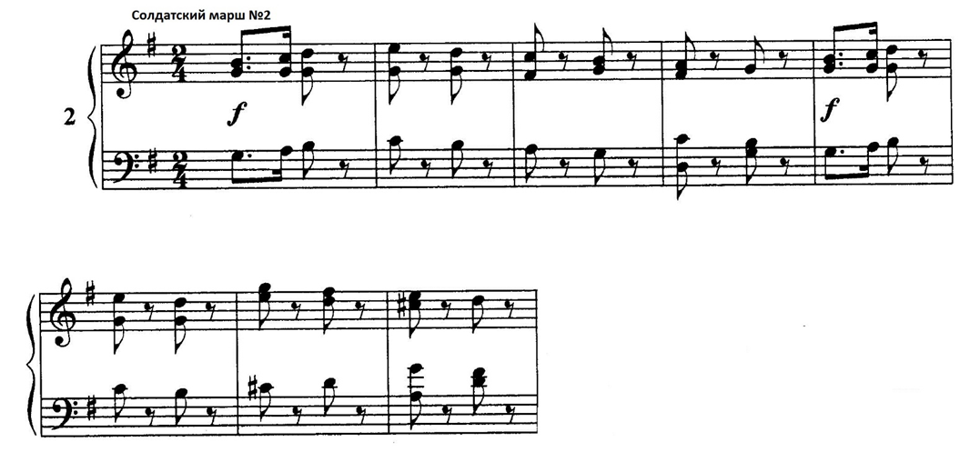
Armes Waisenkind No. 6
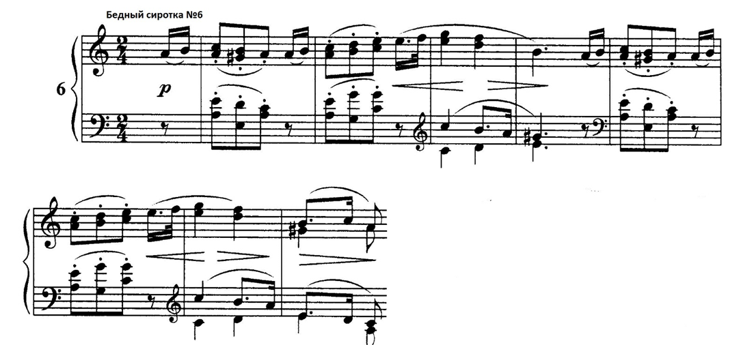
Wilder Reiter No. 8
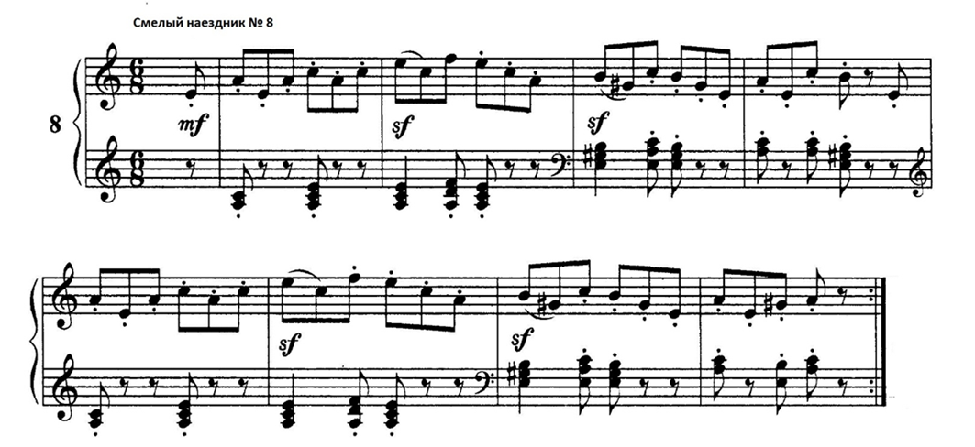

Solfa themes in Round Two No. 1, No. 6, No. 10, No. 17, No. 20, No. 22.

Melodie No.1
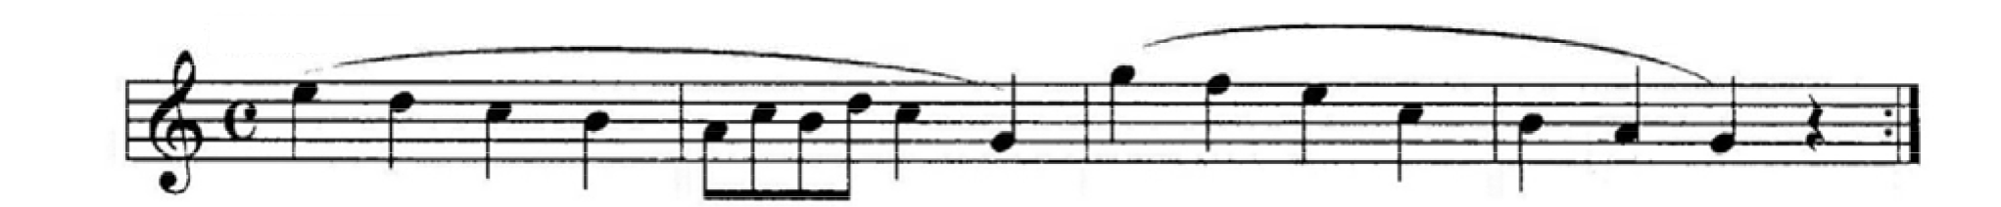
Armes Waisenkind No. 6
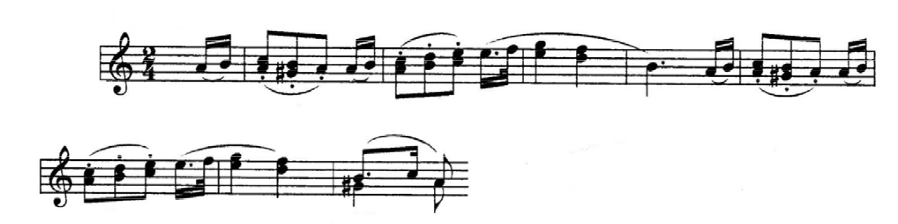
Fröhlicher Landmann No. 10
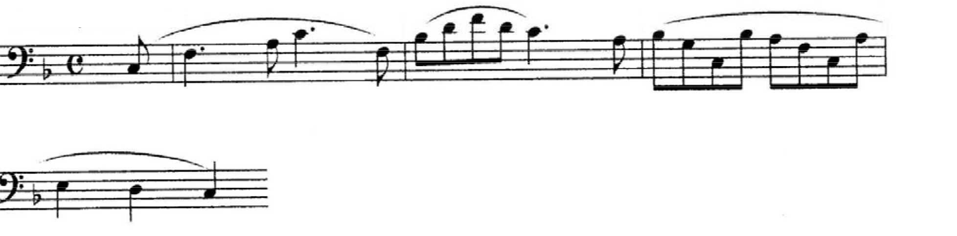
Kleiner Morgenwanderer No. 17
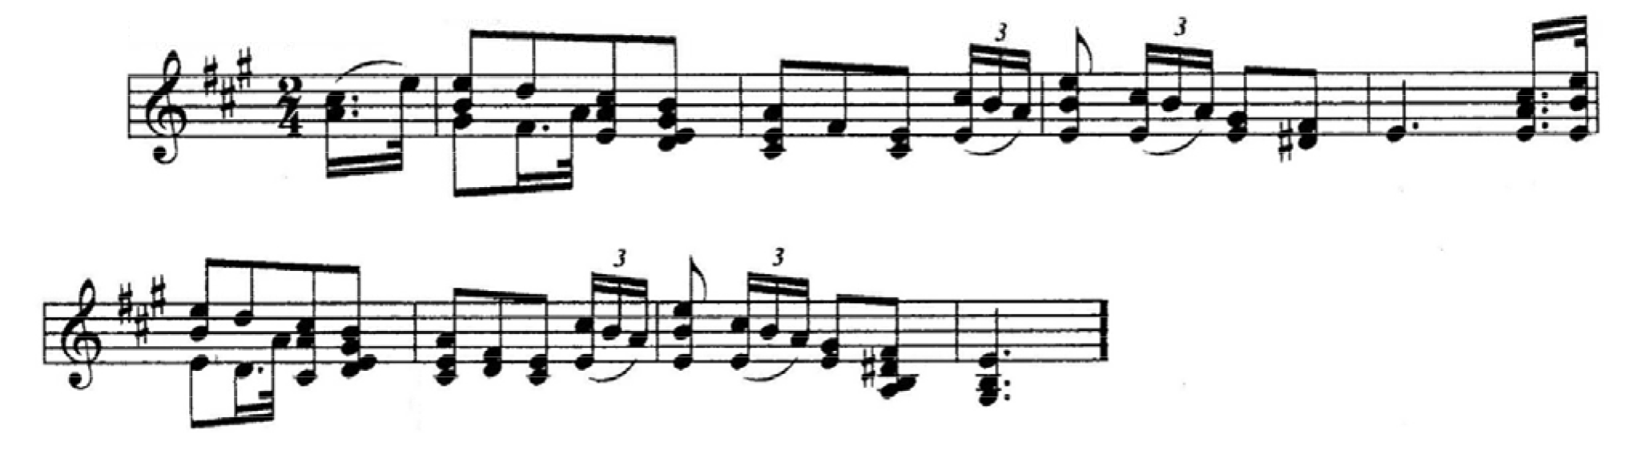
Ländliches Lied – 20
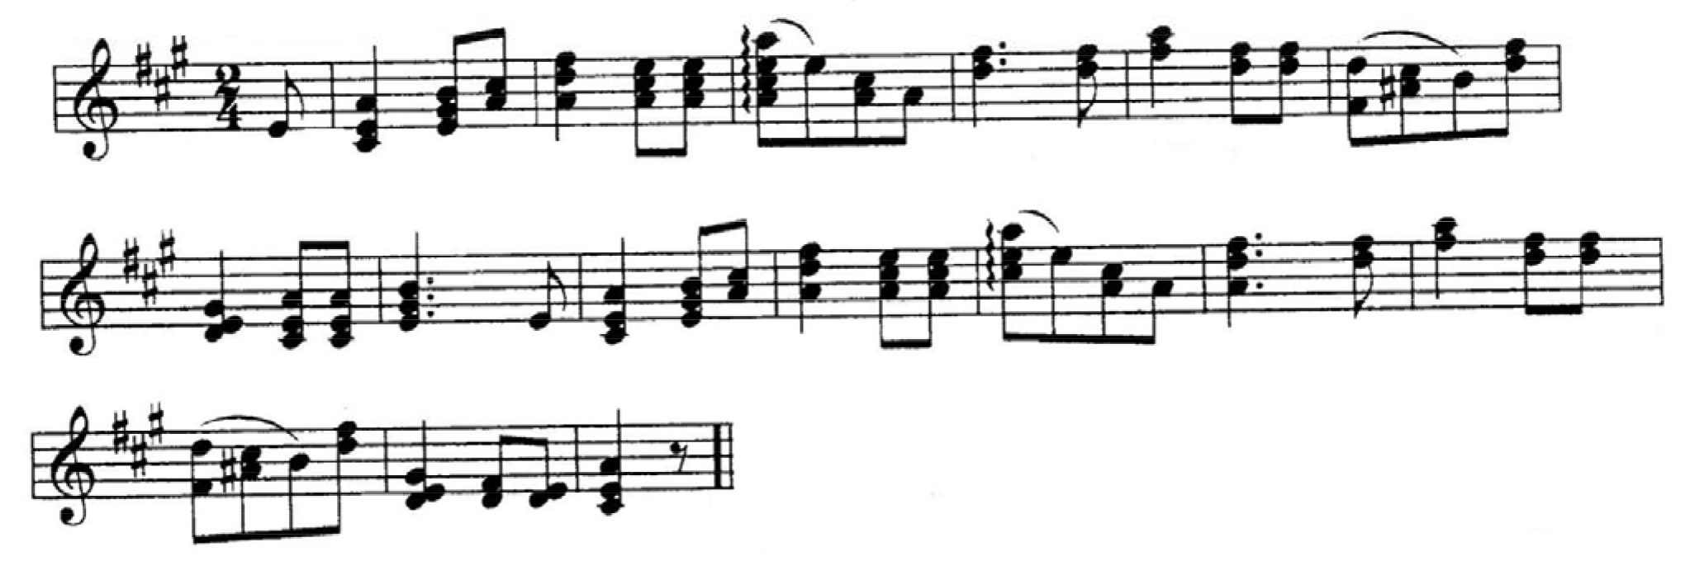
Rundgesang No. 22
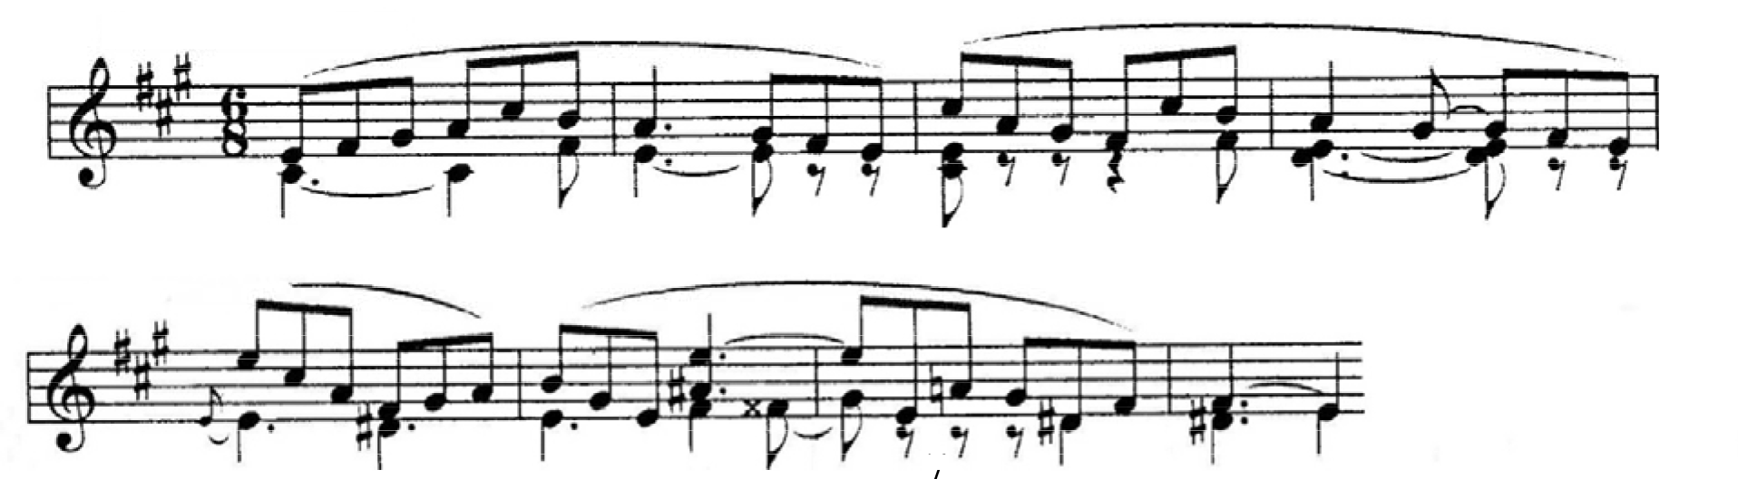

The international children's and youth musical-theoretical competition on knowledge of
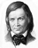
of creativity of Robert Schumann
Contest Card No.
Participant: 1. Full name:
2. Address, telephone, e-mail:
3. Date of birth:
4. Educational institutions (schools, years):

 | Piece name | Round One |  |  |  |  | Round Two
 |  | Test  М | Test  М2 | Test  М3 | Essay | Piece performance | Test  М4 | Note quiz | Theme performance | Singing themes | Story
1 | Melodie
2 | Soldatenmarsch
3 | Trällerliedchen
4 | Ein Choral
5 | Stückchen
6 | Armes Waisenkind
7 | Jägerliedchen
8 | Wilder Reiter
9 | Volksliedchen
10 | Fröhlicher Landmann
11 | Sicilianisch
12 | Knecht Ruprecht
13 | Mai, lieber Mai, Bald bist du wieder da!
14 | Kleine Studie
15 | Frühlingsgesang
16 | Erster Verlust
17 | Kleiner Morgenwanderer
18 | Schnitterliedchen
19 | Kleine Romanze
20 | Ländliches Lied
21 | No. 21***
22 | Rundgesang
23 | Reiterstück
24 | Ernteliedchen
25 | Nachklänge aus dem Theater
26 | No. 26***
27 | Canonisches Liedchen
28 | Erinnerung
29 | Fremder Mann
30 | No.30***
31 | Kriegslied
32 | Scheherazade
33 | “Weinlesezeit – Fröhliche Zeit”
34 | Thema
35 | Mignon
36 | Lied italienischer Marinari
37 | Matrosenlied
38 | Winterzeit I
39 | Winterzeit II
40 | Kleine Fuge
41 | Nordisches Lied
42 | Figurierter Choral
43 | Sylvesterlied
Points for each assignment
Place for each assignment
Accrued points in the round
Place for the round

